No. | Question | Answer
m(H₂SO₄) = x 19.56 = 19.2 g
n(H₂SO₄) = 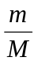 = 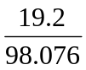= 0.196 mol
n(NH₃) = 2 × n(H₂SO₄) = 2 × 0.196 = 0.392 mol
∴ V(NH₃) = 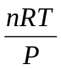 = 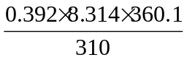 = 3.8 L
At constant temperature and pressure, the mole ratio becomes a volume ratio.
∴ 150 mL CO reacts with 75 mL of oxygen to produce 150 mL of CO₂. 75 mL of O₂ remains unreacted. No CO remains.
n(NaCl) = 500 mol
n(Cl₂)= × n(NaCl) = 250 mol
∴ V(Cl₂) = n × V_{M} = 250 × 24.5 = 6.12 × 10³ L
n(MgO) = = 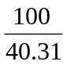 = 2.481 mol
n(CO₂) = n(MgO) = 2.481 mol
∴ V(CO₂) = n × V_{M} = 2.481 × 22.41 = 55.6 L
a Lethal dose is 0.300 g of HCN in 1000 g of air
d(air) = 0.001 18 g mL^{–1} = 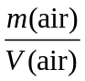
V(1000 g of air) = = 8.475 × 10⁵ mL
mass of HCN in 1 mL = 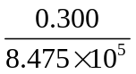= 3.54 × 10^{–7} g
b n(NaCN) = = 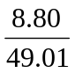 = 0.1796 mol
n(H₂SO₄) = c × V = 0.475 × 0.100 = 0.04750 mol
0.1796 mol of NaCN will react with 0.08980 mol of H₂SO₄; however, we only have 0.047 50 mol
∴ H₂SO₄ is the limiting reagent.
n(HCN) = 2 × n(H₂SO₄) = 2 × 0.047 50 = 0.095 00 mol
V(HCN) = = 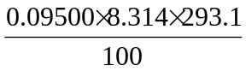 = 2.31 L
 | d = 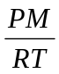 = 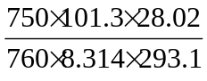 = 1.15 g L^{–1}
 | M = 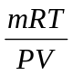 = 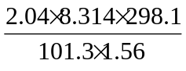 = 32.0 g mol^{–1}
 | d = = 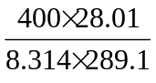 = 4.7 g L^{–1}
M = 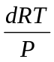 = 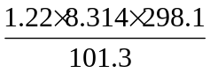 = 29.8 g mol^{–1}
MF = C_{n}H_{2n+2}
∴ 12n + 2n + 2 = 29.8
∴ n = 2
∴ MF = C₂H₆
N : H = 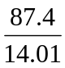 : 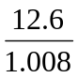 = 6.238 : 12.50 ≈ 1 : 2
∴ EF is NH₂
M = = 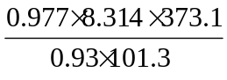 = 32.2 g mol–1
Mass of EF = 14.0 + (2 × 1.0) = 16
Mass of MF = 32.2 ≈ 16 × 2
∴ MF = (NH₂)₂ = N₂H₄

